

<Millennial Web & Mobile App>

# UI/UX

## Introduction

Social media presents businesses with tremendous opportunities to use their influence to catalyze positive change. Content shared on social media has proven to be a powerful tool/weapon in this digital age, allowing citizens to access unlimited information at the click of a button.

Millennialz (MLZ) decentralized news ushers in a collaborative way to share and consume news by breaking open the newsroom and empowering anyone and everyone to participate. Gathering sources, giving tips, funding the stories that matter, and ensuring open access to both TRUTHFUL and TRANSPARENT news is now something that everyone can play a part in.

Put succinctly, Millennialz social-political platform combines real-time news (organic news) from all Local, State, and Federal Government Institutions and rewards content creators for writing news, articles, documentaries, and editorial. It equally rewards readers for liking, reading, reading, liking, commenting, and sharing (RLCS) content on the platform.

# 

Millennialz Logo



## User roles

1. General User Role / Public
   1. Dashboard for all users consist of
2. About me. Do not include Time-line post, Eyewitness post and Articles
3. All basic information
4. followers and following
5. All Read , likes, shares, comments, views and listens should be added
6. User Connections and other social media accounts should be inclusive
7. Eyewitness Media
8. Contributor [Same roles as the public, but will be able to post vetted Articles] To discuss further on a new name and functions

The idea behind the eye witness media is for the general user who is armed with a phone can record live incidents worthy of news. This can be used to collaborate news of a reporter. The user will have the capability to post eyewitness videos and audio recordings. For doing this they will be awarded points …please see publishing page of an Eyewitness for better understanding of the eyewitness publishing procedure

1. Reporters (over 100 reporters from different regions of the country)
2. Editors (over 15 editors)
   1. Main Editors
   2. Regional Editors [Same roles as the editor, but edits News posts sent by other assigned Editors based on assigned states, before sending to the publisher]
3. Representatives (+/- 450 current house of representatives and senators)
4. Publisher (over 10 users)
5. Admins
   1. Sub-Admins [Same roles with Super Admin, but restricted to manage 3 states]
   2. Super-Admins [have all access]
6. Customer service (+/- 25 users)

## Web App Pages

1. **USER AUTHENTICATION MODULE**
   1. PUBLIC/REPORTER/REPRESENTATIVE/EDITOR Pages
      1. Register
      2. Forgot Password
   2. ADMIN/ PUBLIC/REPORTER/REPRESENTATIVE/EDITOR Pages
      1. Login

<https://5sfe4bjft5.millennialzapp.com/app_login.php>

<https://5sfe4bjft5.millennialzapp.com/app_register.php>

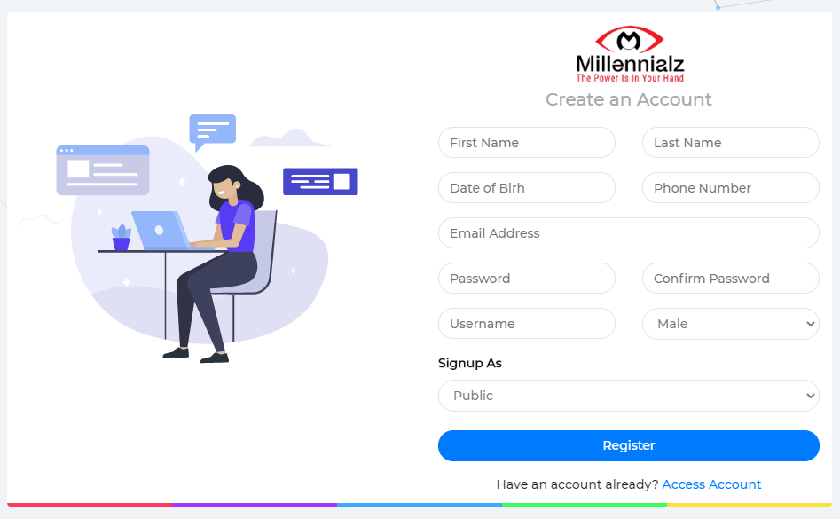

Log-in has to be precise and quick. Like above or something better.

**Note: I agree to the terms and agreement should be included before register**

See below an example of register page with all requirements

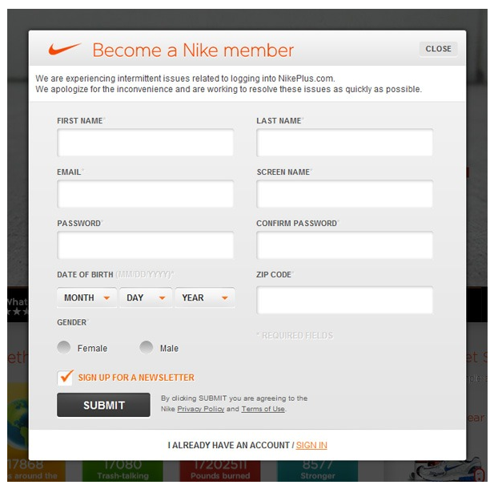

Example of a simple register page

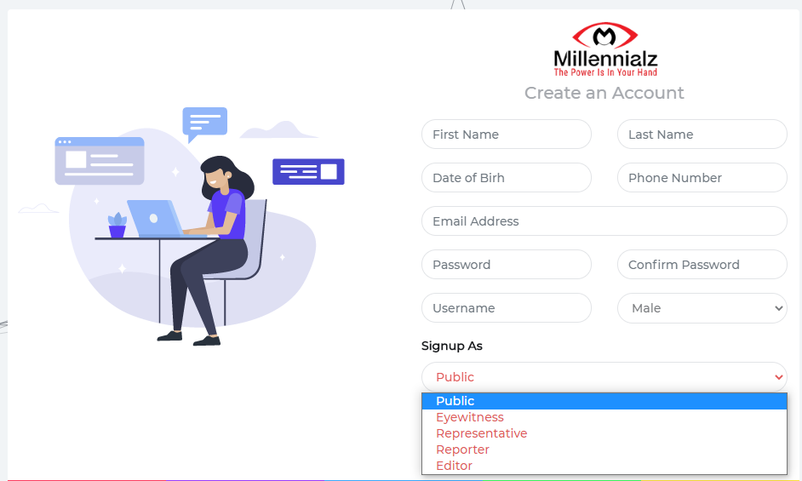

Above is our current register page indicating your choice of registration, this should be redesigned preferably without a DROP down.

***Millennial App Login Instructions***

**STEP1: All users can either sign in or register as a new user when on** [**www.millennialzapp.com**](http://www.millennialzapp.com)

**STEP2: After signing as a registered user, you will be prompted to the TIMELINE page, where users can view all the news associated from their region….**

Below is our current timeline or newsfeed page. We need to redesign to something modern like examples below.

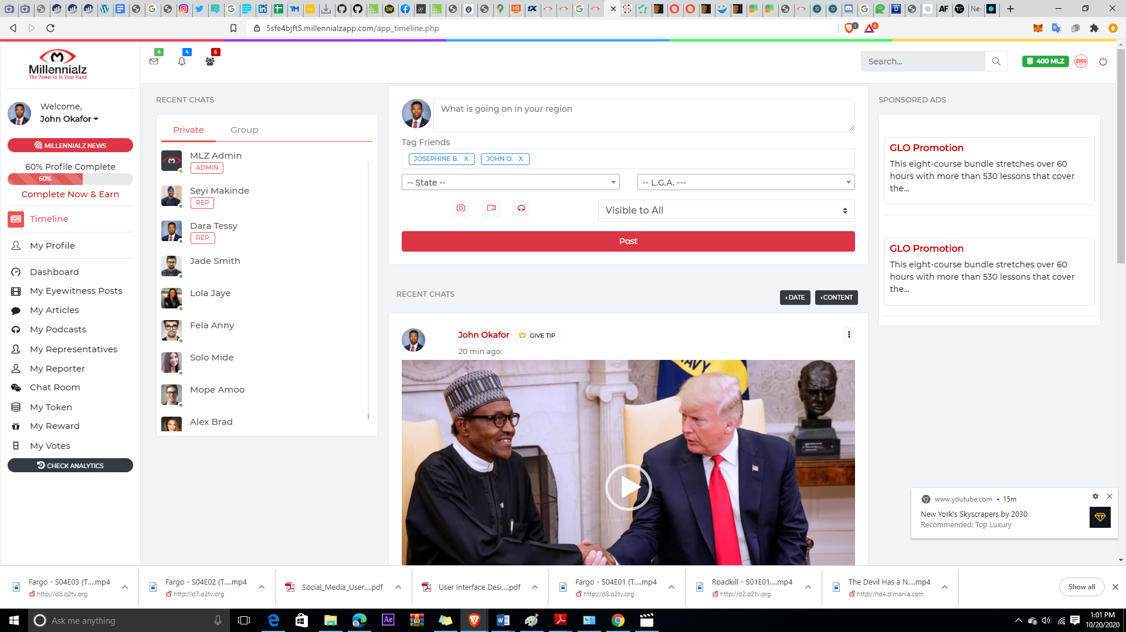

<https://5sfe4bjft5.millennialzapp.com/app_timeline.php>

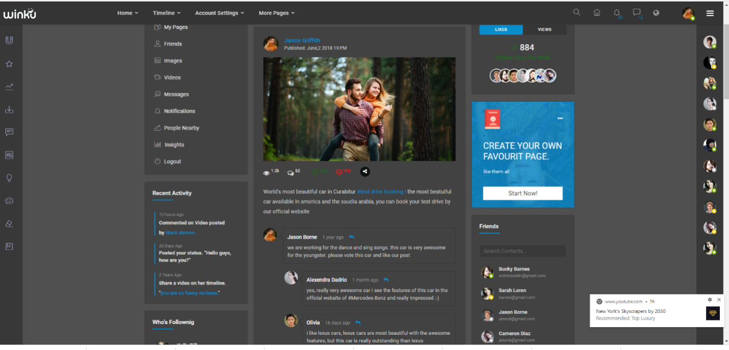

TIMELINE/NEWSFEED Dark and light mode

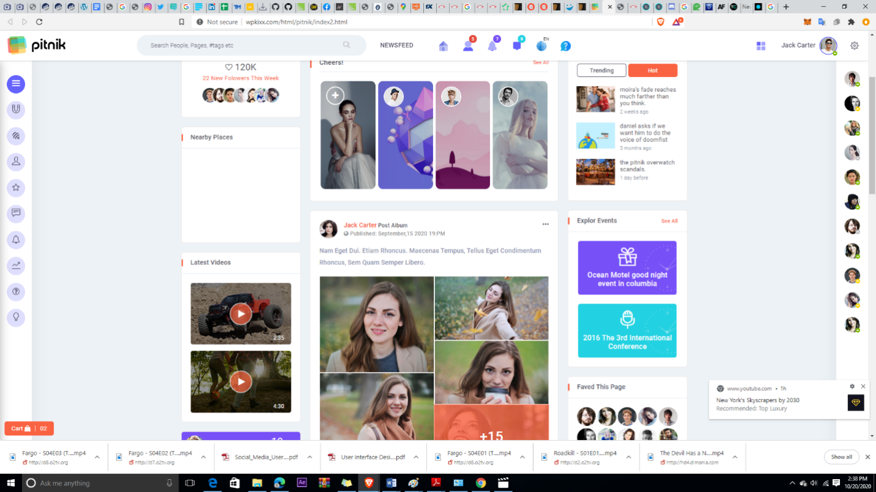

As a new user after registration, they will be promted to create a wallet

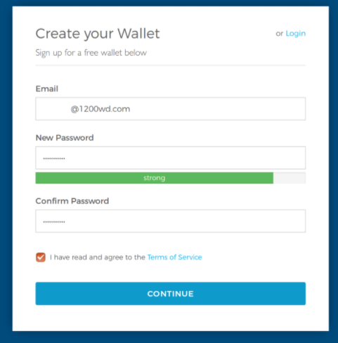

**Once the wallet is created, the user will be prompted to GasUp or proceed to TIMELINE and begin to start earning.**



**A previous registered user will have to gas up if they don’t have money on their account once they push the button on the single news feed page or on the timeline if they wish to like, share, comment, etc**

Fiat (Local currency) Naira will be used to purchase 200, 500,1000,1500,2500, and 3,000 worth of gas

**TIMELINE/NEWSFEED MODULE LOGIC**

The TIMELINE becomes our landing page featuring all the social political news in the users state. For example, if a user signs up at a particular state, that news from that state will be scrolling on their time-line/news feed page. They have the option to read news from other states via list of states from the drop down menu.

Nigeria being our pilot country has 36 states with 744 local governments.

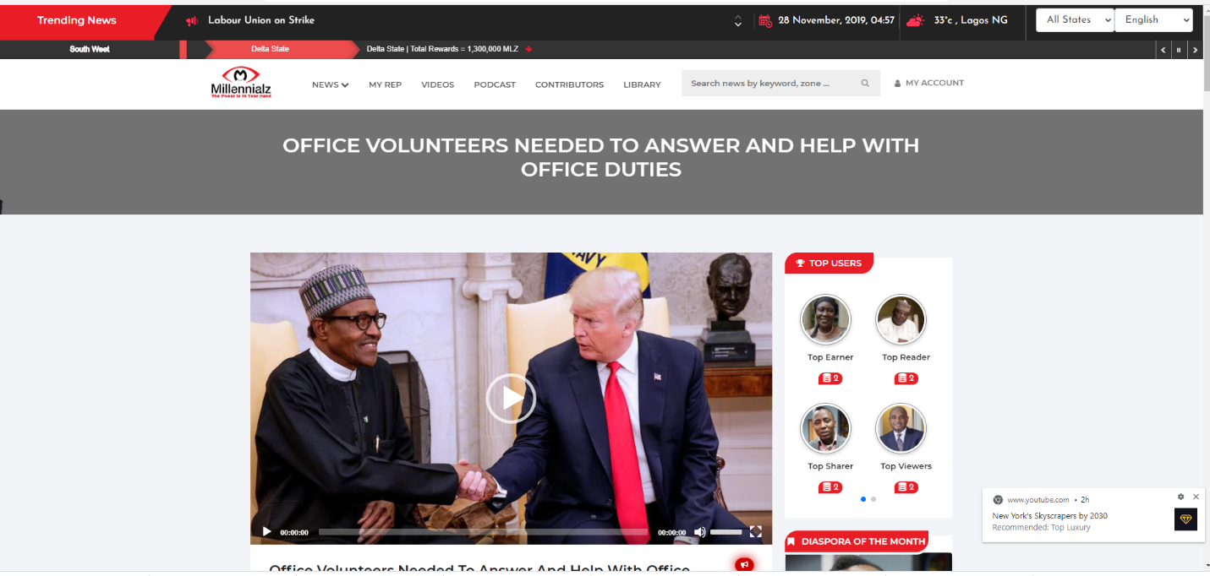

<https://5sfe4bjft5.millennialzapp.com/newsfeed_single.php>

1. **NEWS MODULE (General and State)** [**https://5sfe4bjft5.millennialzapp.com/index.php**](https://5sfe4bjft5.millennialzapp.com/index.php)

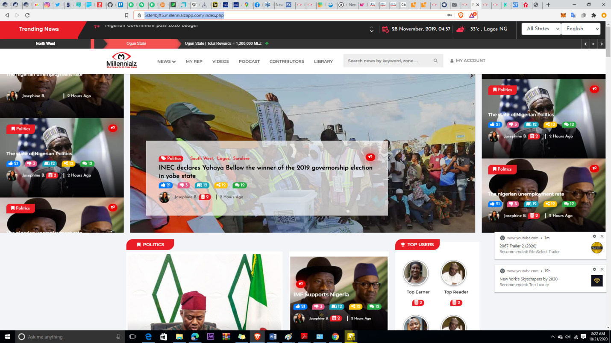

* 1. General News/Home Page - index.php
  2. NEWS Pages
  3. MY-REPRESENTATVE Pages
  4. PODCAST Pages
  5. VIDEOS Pages
  6. LANDING Pages
     1. Millennialz Overview - newsfeed_millenialz.php
     2. About Us - newsfeed_about_us.php
     3. Our Services - newsfeed_services.php
     4. FAQ - newsfeed_faq.php
     5. Advertise with Us - #
     6. Contact Us - newsfeed_contact_us.php
     7. newsfeed_privacy_policy.php
     8. newsfeed_terms.php
     9. newsfeed_search.php
  7. ARTICLE Pages
  8. Call to Action (CTA )Pages

***** see example of a better design for news page below*****

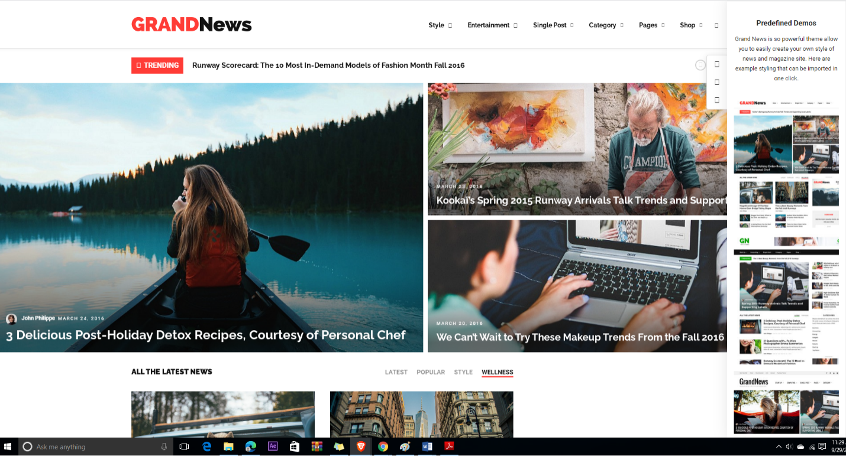 https://themes.themegoods.com/grandnews/demo1/ https://themes.themegoods.com/grandnews/demo1/

1. **SOCIAL MODULE**
   1. **CHATROOM**
      1. PUBLIC Pages
      2. ADMIN Pages
   2. **TIMELINE**
      1. PUBLIC Pages All information such as news , videos,

podcast, articles and post will now appear on the

newsfeed page.

* + 1. ADMIN Pages
  1. **CTA (Call to Action)**
     1. NEWSFEED Pages
     2. PUBLIC Pages
     3. ADMIN Pages

All the above functions should be combined effectively



1. **USER ROLES MODULE** [**https://5sfe4bjft5.millennialzapp.com/app_public_dashboard.php**](https://5sfe4bjft5.millennialzapp.com/app_public_dashboard.php)
   1. PUBLIC pages
      1. MY-EYEWITNESS Pages
      2. MY-ARTICLES Pages
      3. MY-REPRESENTATIVE Pages
      4. MY-REPORTER Pages
      5. OTHER Pages
         1. Dashboard - app_public_dashboard.php
         2. Profile app_public_profile.php
         3. Settings - app_public_setting.php

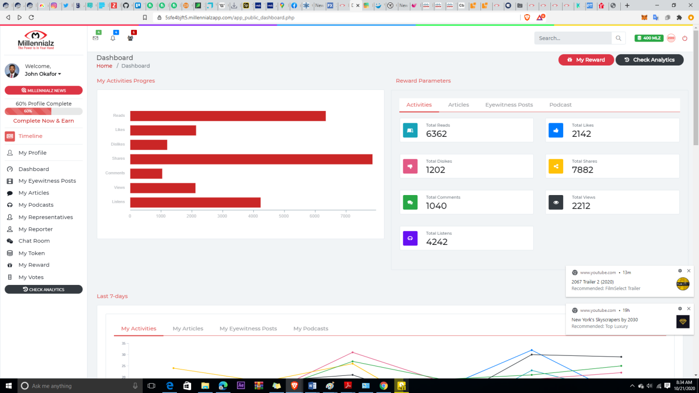

* 1. REPORTER Pages <https://5sfe4bjft5.millennialzapp.com/app_reporter_dashboard.php>
     1. MY-NEWS Pages
     2. MY-EDITOR Pages
     3. OTHER Pages
        1. Dashbaord - app_public_dashboard.php
        2. Profile app_public_profile.php
        3. Settings - app_public_setting.php

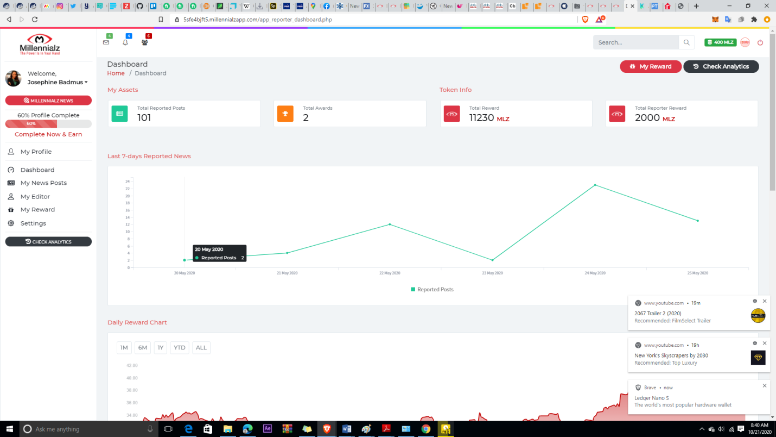

* 1. EDITOR Pages
     1. MY-NEWS Pages [If approved to be a REPORTER]
     2. EDIT NEWS Pages
     3. EDIT ARTICLES Pages
     4. EDIT EYEWITNESS POSTS Pages
     5. MY-REPORTER Pages
     6. MY-EDITOR Pages [If approved to be a REGIONAL EDITOR]
     7. OTHER Pages
        1. Dashbaord - app_public_dashboard.php
        2. Profile app_public_profile.php
        3. Settings - app_public_setting.php

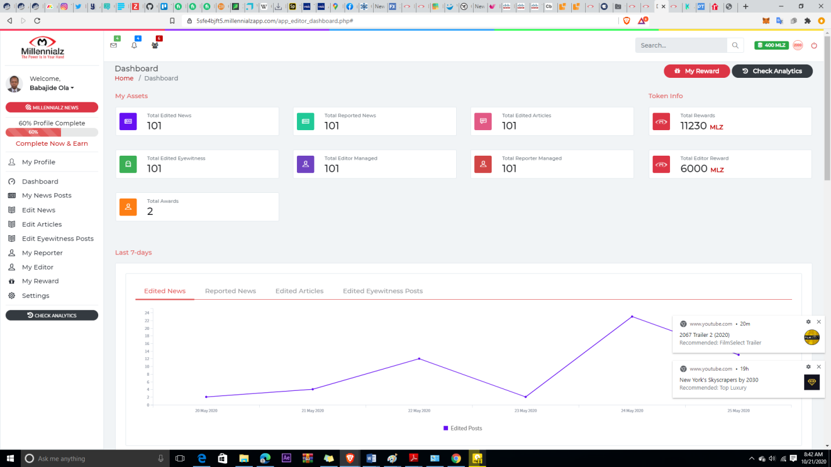

* 1. PUBLISHER Pages
     1. MY- PODCAST Pages
     2. PUBLISH NEWS Pages
     3. PUBLISH ARTICLES Pages
     4. PUBLISH EYEWITNESS POSTS Pages
     5. MY-EDITOR Pages
     6. OTHER Pages
        1. Dashboard - app_public_dashboard.php
        2. Profile app_public_profile.php
        3. Settings - app_public_setting.php

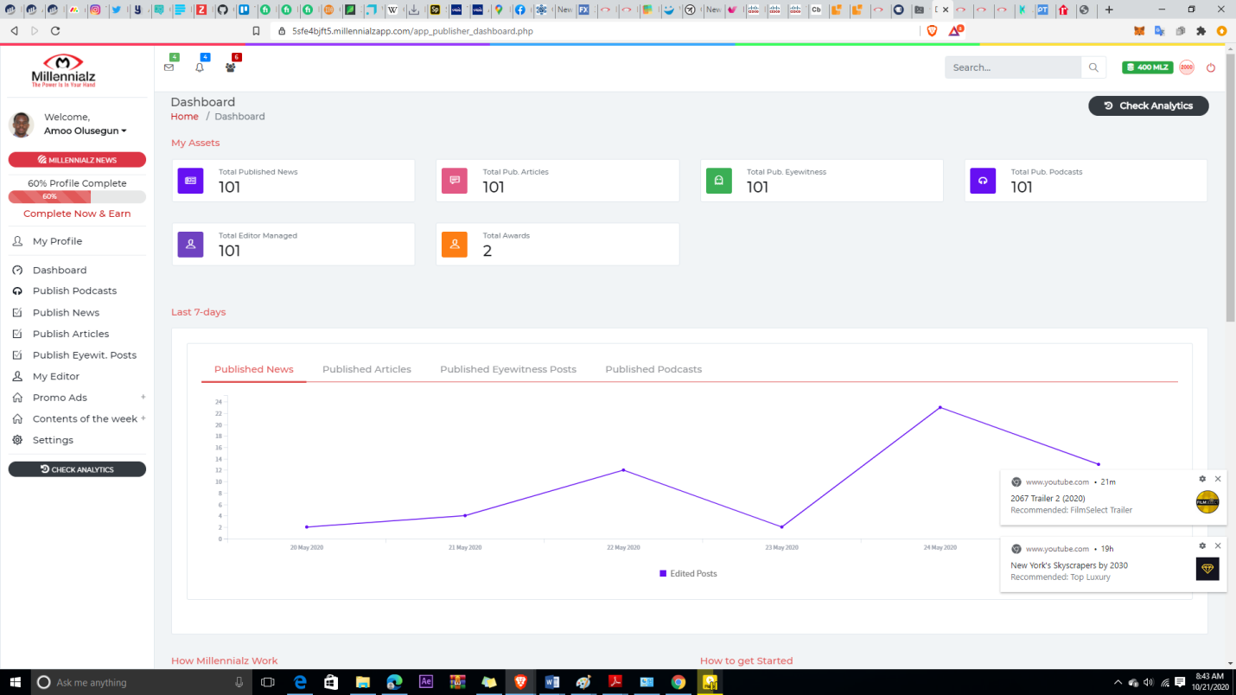

* 1. REPRESENTATIVE Pages
     1. EMERGENCY-BROADCAST Pages
     2. CONSTITUENCY ISSUES Pages
     3. OTHER Pages
        1. Dashboard - app_public_dashboard.php
        2. Profile app_public_profile.php
        3. Settings - app_public_setting.php

Users, will have the opportunity to search and read about their representatives. Representatives can CLAIM their page and upload their achivements or video for communicatoion with their constuencies. It’s a virtual office for all representative

<https://5sfe4bjft5.millennialzapp.com/newsfeed_representative_find.php>

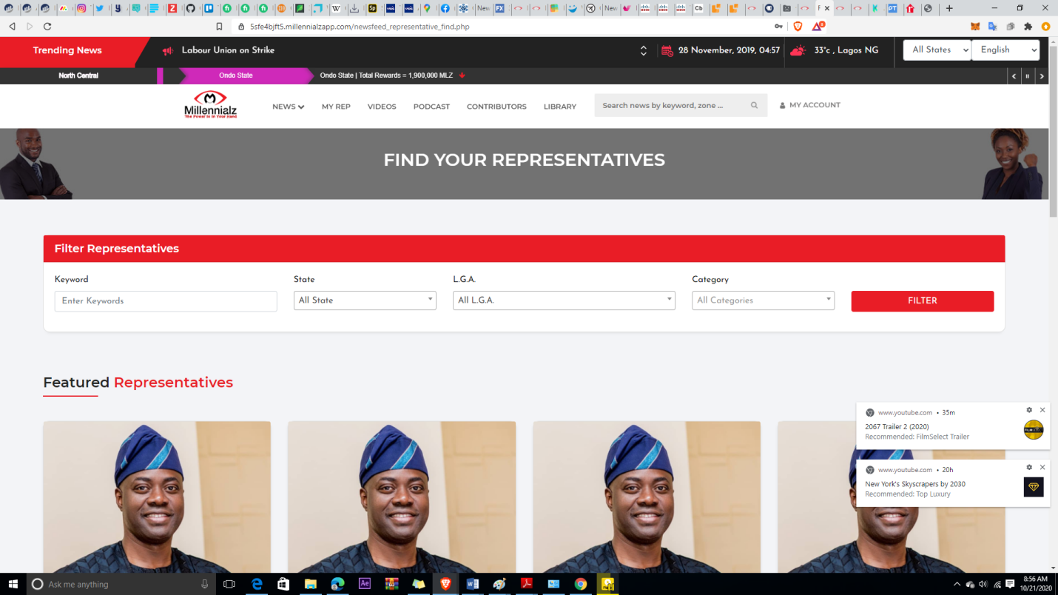

* 1. ADMIN Pages
     1. Manage Attributes
     2. Manage Contents
     3. Manage User Roles
     4. Manage Votes
     5. Manage Gas-up
     6. Mange Emails
     7. OTHER Pages
        1. App_admin_dashboard.php
        2. app_admin_profile.php
        3. app_admin_setting.php

[**https://5sfe4bjft5.millennialzapp.com/app_admin_dashboard.php**](https://5sfe4bjft5.millennialzapp.com/app_admin_dashboard.php)

**Please navigate the above link for better understanding and figure out how best to redesign the admin**

1. **REWARD MODULE**
   1. NERWSFEED pages
   2. PUBLIC Pages
      1. Reward Pages
      2. Token Pages
   3. REPORTER Pages
      1. Reward Pages
   4. REPRESENTATIVE Pages
      1. Reward Pages
   5. EDITOR Pages
      1. Reward Pages
   6. PUBLISHER Pages
      1. Reward Pages
   7. ADMIN Pages
      1. Manage Rewards pages
      2. Manage Token Pages

[**https://5sfe4bjft5.millennialzapp.com/app_editor_reward_editednews.php**](https://5sfe4bjft5.millennialzapp.com/app_editor_reward_editednews.php)

1. **PAYMENT API MODULE**
   1. GAS-UP pages for users
   2. ADMIN Pages
2. **SOCIAL MODULE**
   1. **CHATROOM**
      1. PUBLIC Pages
      2. ADMIN Pages
   2. **TIMELINE**
      1. PUBLIC Pages
      2. ADMIN Pages
   3. **CTA**
      1. NEWSFEED Pages
      2. PUBLIC Pages
      3. ADMIN Pages

<https://5sfe4bjft5.millennialzapp.com/newsfeed_cta.php>

1. **ANALYTICS MODULE**
   1. PUBLIC
      1. Complete Analysis charts & functions on Dashboard
      2. Analytics Pages
   2. REPORTER
      1. Complete Analysis charts & functions on Dashboard
      2. Analytics Pages
   3. REPRESENTATIVE
      1. Complete Analysis charts & functions on Dashboard
      2. Analytics Pages
   4. EDITOR
      1. Complete Analysis charts & functions on Dashboard
      2. Analytics Pages
   5. PUBLISHER
      1. Complete Analysis charts & functions on Dashboard
      2. Analytics Pages
   6. ADMIN
      1. Complete Analysis charts & functions on Dashboard
      2. All Stats pages
      3. General Analytics Pages

[**https://5sfe4bjft5.millennialzapp.com/app_public_analytics.php**](https://5sfe4bjft5.millennialzapp.com/app_public_analytics.php)

1. **PROMOTION/ADVERTISING MODULE**
   1. Allocate Ad-spaces on Newsfeed Pages
   2. Allocate Ad-spaces on User Role Pages
   3. Manage Promotions [Admin]

<https://5sfe4bjft5.millennialzapp.com/app_publisher_promoads.php>

1. **VOTE MODULE**
   1. PUBLIC Pages
   2. ADMIN Pages

[**https://5sfe4bjft5.millennialzapp.com/app_vote_view.php#**](https://5sfe4bjft5.millennialzapp.com/app_vote_view.php#)

1. **GAMIFICATION MODULE**
2. **MARKET PLACE MODULE**

## Proposed new system

### New system

We are proposing using a new system from the current one to MEAC which is the framework that is gaining the most wide adoption now. Node.js. does a good job of addressing the above questions:

1) it's a framework with emerging conventions;

2) great for real-time (event-driven with non-blocking I/O, which allows for massive parallelization);

3) it's written in JavaScript, the most common language for new libraries and SDKs, and 4) it's capable of massive scale (it's used by companies like Walmart, Microsoft and LinkedIn).

## Proposed System

**Node.js** is an open-source asynchronous event-driven JavaScript runtime environment, mainly used to build scalable applications. Node.js is also an ideal choice for building microservices solutions, event queues, WebSockets. It also makes a popular choice for back-end because of event-driven architecture, and it is free from dead-locking, which makes scalable applications.

Node.js offers amazing features as Node.js environment is convenient for serverside applications. Also, JS works flawlessly on Linux, Mac OS, and Windows with Node.js runtime environment.

Even more, Node.js enables faster code execution since it is built on the Google V8 JavaScript engine.

Also, giants like Netflix, LinkedIn, PayPal, Walmart, Microsoft, IBM and more are using Node.js for their application.

**REACT**

React is front-end JavaScript library maintained by Facebook. To make interactive UI(User Interface), ReactJS requires fewer efforts compare to others. Since React will proficiently update and render the perfect components when your information changes if you designed a basic view for every state in your React application.